AI-powered Healthcare Assistant: A Comprehensive approach to Medical Support Systems

**PROJECT REPORT**

Submitted by

**ASWATHY UDAYAN PRC22CA009**

**BINTA ANN BENNY PRC22CA010**

**SHESNA S PRC22CA025**

To

*APJ Abdul Kalam Technological University*

*in partial fulfillment of the requirements for the award of B.Tech Degree in Computer Science and Engineering*

*(Artificial Intelligence)*



# Department of Artificial Intelligence

# Providence College of Engineering, Chengannur March 2025

DEPARTMENT OF ARTIFICIAL INTELLIGENCE

**PROVIDENCE COLLEGE OF ENGINEERING, CHENGANNUR**





**CERTIFICATE**

Certified that this report entitled ‘*AI-powered Healthcare Assistant: A Comprehensive Approach to Medical Support Systems’* is the report of project completed by the following students during **2024-2025** in partial fulfillment of the requirements for the award of the Degree of Bachelor of Technology in Computer Science and Engineering(Artificial Intelligence).

|  |  |
| --- | --- |
| **ASWATHY UDAYAN** | **PRC22CA009** |
| **BINTA ANN BENNY** | **PRC22CA010** |
| **SHESNA S** | **PRC22CA025** |
|  |  |

**Dr. Anoop P S** (Project Supervisor)

Associate Professor, Department of Artificial Intelligence (AI)

**Dr. Prem Shankar** (Mini Project Coordinator)

HoD - AI

Department of Artificial Intelligence (AI)

Providence College of Engineering, Chengannur

**DECLARATION**

We, hereby declare that, this project report entitled ‘*AI-powered Healthcare Assistant: A Comprehensive Approach to Medical Support Systems’* is the bonafide work of ours carried out under the supervision of **Dr. Anoop P S**, Associate Professor, Department of Artificial Intelligence. We declare that, to the best of our knowledge, the work reported herein does not form part of any other project report or dissertation on the basis of which a degree or award was conferred on an earlier occasion to any other candidate. The content of this report is not being presented by any other student to this or any other university for the award of a degree.



|  |  |  |  |
| --- | --- | --- | --- |
| **Sl. No.** | **Name of Student** | **Roll Number** | **Signature** |
| 1 | ASWATHY UDAYAN | PRC22CA009 |  |
| 2 | BINTA ANN BENNY | PRC22CA010 |  |
| 3 | SHESNA S | PRC22CA025 |  |

Dr. Anoop P S (Project Supervisor)

Dr. Prem Sankar C

Head of Department – Computer Science and Engineering (AI)

Providence College of Engineering

Date: 31/03/2025

# ACKNOWLEDGEMENTS

We take this opportunity to express our deep sense of gratitude and sincere thanks to all who helped us to complete this project successfully.

We are deeply indebted to our Project Supervisor **Dr. Anoop P S**, Associate Professor for his excellent guidance, positive criticism, and valuable comments. We express our sincere gratitude to our project coordinator **Dr. Prem Sankar C**, Associate Professor for his timely guidelines and critical reviews.

We are also greatly thankful to our Head of Department **Dr. Prem Sankar C,** Associate Professor for his continuous support. We also thank the other department faculty members who helped us in doing this project work.

Finally, we thank our parents, family members and friends who directly and indirectly contributed to the successful completion of our main project.

Aswathy Udayan

Binta Ann Benny

Shesna S

Date: 31/03/2025

# ABSTRACT

Access to reliable healthcare remains a challenge, as many individuals struggle to interpret medical data, recognize symptoms, and make informed health decisions. To address this, we propose **"AI-powered Healthcare Assistant: A Comprehensive Approach to Medical Support Systems."** Our system focuses on an AI-driven **symptom checker** that processes both text and image inputs to assist users in identifying potential health concerns. By leveraging **advanced AI models and Retrieval-Augmented Generation (RAG),** the assistant delivers real-time medical insights based on verified information. The system is designed to be user-friendly, ensuring seamless interaction through an intuitive interface. This project contributes to improving health awareness, early detection of medical conditions, and accessibility to AI-assisted healthcare solutions.

**Keywords**: AI-powered Healthcare, Symptom Analysis, Medical Data Interpretation, RAG, Text and Image Processing, AI-driven Health Assistant.

**TABLE OF CONTENTS**

ACKNOWLEDGEMENTS i

ABSTRACT ii

LIST OF FIGURES v

LIST OF TABLES vii

LIST OF ABBREVIATIONS viii

CHAPTER 1 1

INTRODUCTION 1

* 1. 1.1 Background 1
  2. 1.2 Existing System 1
  3. 1.3 Problem Statement 2
  4. 1.4 Objectives 2
  5. 1.5 Scope 3

CHAPTER 2 4

LITERATURE REVIEW 4

CHAPTER 3 11

SYSTEM ANALYSIS 11

* 1. 3.1 Functional Requirements 11
  2. 3.2 Non-Functional Requirements 12
  3. 3.3 Feasibility Analysis 13
     1. 3.3.1 Technical feasibility 13
     2. 3.3.2 Operational feasibility 13
     3. 3.3.3 Economic feasibility 13
  4. 3.4 Hardware Requirements 13
  5. 3.5 Software Requirements 14
  6. 3.6 Life Cycle Used 14
  7. 3.7 Cost Estimation……………………………………………………………15

3.8 Project Scheduling using Gantt chart 15

CHAPTER 4 00

METHODOLOGY 00

* 1. 4.1 Proposed System 00
  2. 4.2 Modular Decomposition 00
  3. 4.3 Algorithm 00
  4. 4.4 Advantages of Proposed System 00

CHAPTER 5 00

SYSTEM DESIGN 00

* 1. 5.1 Flow Chart 00
  2. 5.2 Use Case Diagram 00
  3. 5.3 Activity Diagram 00
  4. 5.4 Sequence Diagram 00
  5. 5.5 Collaboration Diagram 00
  6. 5.6 Circuit Diagram……………………………………………………………00

REFERENCES 17

# LIST OF FIGURES

|  |  |  |
| --- | --- | --- |
| **Figure number** | **Figure Name** | **Page Number** |
| Figure 1.1 | Agile Model | 14 |
| Figure 3.1 | Project Scheduling using Gantt chart | 15 |
|  |  |  |
|  |  |  |
|  |  |  |
|  |  |  |
|  |  |  |
|  |  |  |
|  |  |  |
|  |  |  |
|  |  |  |
|  |  |  |
|  |  |  |
|  |  |  |
|  |  |  |
|  |  |  |
|  |  |  |
|  |  |  |
|  |  |  |
|  |  |  |
|  |  |  |
|  |  |  |
|  |  |  |
|  |  |  |
|  |  |  |
|  |  |  |

|  |  |  |
| --- | --- | --- |
|  |  |  |
|  |  |  |
|  |  |  |
|  |  |  |

|  |  |  |
| --- | --- | --- |
|  | **LIST OF TABLES** |  |
| **Table Number** | **Table Name** | **Page Number** |
| Table3.1 | COCOMO Model Coefficients | 14 |
| Table 3.2 | Project timeline | 15 |

# LIST OF ABBREVIATIONS

|  |  |
| --- | --- |
| **Abbreviation** | **Expansion** |
| AI | Artificial Intelligence |
| API | Application Programming Interface |
| COCOMO | Constructive Cost Model |
| CSV | Comma-Separated Values |
| DB | DataBase |
| DL | Deep Learning |
| JSON | JavaScript Object Notation |
| LLM | Large Language Model |
| ML | Machine Learning |
| NLP | Natural Language Processing |
| OCR | Optical Character Recognition |
| RAM | Random Access Memory |
| RAG | Retrieval-Augmented Generation |
| REST API | Representational State Transfer API |
| SDK | Software Development Kit |
| SQL | Structured Query Language |
| UI | User Interface |
| UX | User Experience |
| VM | Virtual Machine |
| XML | Extensible Markup Language |

**CHAPTER 1 INTRODUCTION**

## 1.1 Background

Access to reliable healthcare is often a challenge, as many individuals struggle to recognize symptoms and determine when to seek medical attention. Uncertainty in identifying health concerns can lead to unnecessary stress or delays in treatment. With the rise of artificial intelligence, technology-driven healthcare solutions have the potential to assist individuals by providing preliminary symptom assessments and guiding them toward appropriate medical decisions.

The **AI-powered Healthcare Assistant** is designed to address this need by serving as an intelligent **symptom checker** that processes both text and image-based inputs. Using **Natural Language Processing (NLP) for text analysis** and **computer vision for image-based symptom recognition**, the system helps users assess their health concerns and receive relevant insights. By integrating **verified medical data and AI-driven models**, it offers real-time symptom evaluation, bridging the gap between users and healthcare professionals.

This AI-powered system is designed to improve healthcare accessibility by encouraging early symptom identification and proactive health management. Through an intuitive and user-friendly interface, it empowers individuals to make informed decisions about their health while reducing unnecessary medical visits.

## 1.2 Existing System

Many healthcare assistance systems are **fragmented and limited in scope**, making it difficult for users to access accurate and reliable symptom analysis in one place. While some applications offer **basic symptom checkers**, they often rely on predefined databases or rule-based models that lack adaptability. These systems provide general symptom assessments but do not incorporate **advanced AI techniques** for dynamic and context-aware medical insights.

Existing AI-based medical assistants and chatbots have several limitations::

* **Static Symptom Databases:** Many rely on predefined symptom lists instead of using advanced models like **LLMs and Retrieval-Augmented Generation (RAG)** for real-time, context-aware responses.
  + - **Lack of Image-based Symptom Analysis**: Most systems only process text inputs, failing to leverage **computer vision** for detecting visual symptoms.
    - **Limited Context Awareness**: Many chatbots provide generic symptom suggestions without considering additional user inputs or evolving medical knowledge.
    - **Inconsistent Accuracy**: Rule-based models may struggle with **ambiguous or complex symptoms**, leading to inaccurate assessments.
    - **Privacy & Security Concerns:** Some systems lack proper **data security measures**, making it difficult to ensure compliance with healthcare regulations.

## 1.3 Problem Statement

To develop an **AI-powered symptom checker** that enhances healthcare accessibility by analyzing **text and image-based symptom inputs**. The system will utilize **Natural Language Processing (NLP) for text-based symptom assessment** and plans to integrate **computer vision for image-based symptom recognition**. By leveraging **LLMs and Retrieval-Augmented Generation (RAG),** the assistant will provide real-time, AI-driven medical insights, helping users better understand their symptoms and make informed health decisions.

## 1.4 Objectives

The following are some of the goals of this proposed paradigm:

* + - **To develop an AI-powered symptom checker** capable of analyzing **both text and image-based inputs** for early symptom detection.
    - **To implement NLP and AI-based models** for accurate symptom interpretation and health insights.
    - **To enhance accessibility** by providing **real-time, AI-driven symptom assessments** to users.
    - **To create a user-friendly and scalable system** that can assist individuals in making informed health decisions.
    - **To improve healthcare awareness** by leveraging AI to offer preliminary symptom analysis and guidance.

## 1.5 Scope

The system provides an **AI-powered symptom checker** designed to assist individuals in identifying potential health concerns through **text and image-based symptom analysis**. By leveraging **Natural Language Processing (NLP) and AI-driven insights**, it offers users preliminary symptom assessments, helping them make informed health decisions. This **user-friendly and accessible** tool promotes early symptom recognition, increasing health awareness and improving the overall healthcare experience.

# CHAPTER 2 LITERATUREREVIEW

This chapter is about the various existing work in the field of AI-powered Healthcare Assistant Chatbots. The summary of the most relevant 12 papers is provided below.

**S. Manikandan et al.** have proposed a model [1] for developing an AI-Powered Healthcare Chatbot Using Natural Language Processing for Symptom Analysis and Medical Assistance. They can provide basic diagnoses, suggest basic treatments, and recommend precautions based on the symptoms described by users before seeing a doctor. They have used Natural Language Processing (NLP) technology to help the chatbot understand user questions and also employed the Natural Language Toolkit (NLTK) for processing and analyzing user inputs inorder to provide symbolic and statistical natural language processing, allowing the chatbot to understand and respond to queries in a human-like manner. They have implemented this model in the healthcare domain, focusing on initial symptom analysis and helping users to decide whether to seek professional care. Their model shows several advantages like the chatbot’s user-friendly interface ensures accessibility for individuals of all technological skills, making it a versatile tool for a wide variety of users, encourages users to take charge of their health and well-being, promoting a culture of self-care and preventive medicine. The system also aids in health awareness by providing information on diseases, treatments, and preventive measures. But their model fails to handle complex diagnoses and requires healthcare professionals for validation to ensure medical accuracy. Other challenges like ensuring data security, managing algorithmic bias, and maintaining updated medical databases are some limitations in their implementation.

**Jomana Anwar et al.** have proposed a model [2] for developing a chatbot-based first aid service in the Arabic language to assist users during emergency situations. They have used Natural Language Processing (NLP) techniques, including intent classification and similarity modules, fine-tuning pre-trained language models such as AraBERTv2 for resolving the challenges of providing timely and accurate first aid information in Arabic, a language with complex morphology and dialectal variations. They have implemented this model in the domain of emergency first aid services, focusing on Modern Standard Arabic (MSA). Their model shows significant merits, including providing real-time, contextually accurate first aid instructions, empathetic interactions for user comfort, and the ability to classify and respond to diverse emergency queries. Additionally, the system demonstrates user satisfaction through evaluations using the Technology Acceptance Model (TAM). However, their model fails to address the need for support in dialectal Arabic and has limited coverage of emergency topics. Future work is required to enhance the similarity model and expand the chatbot’s domain-specific knowledge base.

**Tathagat Yadav & Ankit yadav** have proposed a model [3] for designing and developing a MediBot system to predict diseases based on symptoms provided by users. They have used the Apriori algorithm for symptom-disease mapping and Recurrent Neural Network (RNN) for enabling conversational capabilities, resolving the issues of early disease detection and providing accessible medical assistance. They have implemented this model in the healthcare domain, focusing on disease prediction and general health conversations. Their model shows significant merits, such as providing early disease predictions, enabling users to monitor their health conveniently, and offering a conversational interface for better engagement. Additionally, the use of machine learning ensures adaptability and improved prediction accuracy over time. However, their model fails to address challenges like the lack of comprehensive medical datasets and the high training time required for RNN models. Future work suggests improving dataset availability and integrating offline speech-to-text APIs for enhanced usability

**Chaturvedi U et al.** have proposed a model [4] to examined the role of artificial intelligence in remote healthcare, with a focus on improving patient interaction, connectivity, and overcoming existing barriers. Their study highlights AI-driven remote monitoring systems that use biosensors and wearable devices to detect health irregularities early, allowing for timely medical intervention. They also discuss the impact of AI-powered chatbots and virtual assistants in providing personalized healthcare guidance, improving patient adherence to treatments. Furthermore, the research explores AI’s ability to enhance telemedicine services, making healthcare more accessible to remote and underserved communities. While their findings suggest that AI strengthens remote healthcare by optimizing communication and decision-making, they also acknowledge key challenges such as data security concerns, the need for better digital infrastructure, and biases in AI algorithms. Future advancements should focus on addressing these issues through improved regulatory measures, greater transparency in AI systems, and expanding access to AI-driven healthcare for all.

**Shafaq Fatima Mughal et al.** have proposed a model [5] for designing a domain-specific chatbot, "Mai," to enhance menstrual health education among women in South Asia, specifically Pakistan. They have used DialoGPT’s transformer architecture fine-tuned on English and Roman Urdu datasets for resolving the challenges of providing culturally sensitive and accurate menstrual health information. They have implemented this model in the domain of menstrual health, focusing on stigma reduction and improving access to menstrual hygiene education. “Their model shows significant merits, including providing personalized and contextually accurate information in multiple languages, achieving strong performance metrics such as high BERTScore and ROUGE-L, and receiving positive feedback from users and medical professionals during evaluations.”. However, their model fails to address challenges like biases in datasets, the difficulty of generating responses for complex queries, and reliance on internet-based APIs, which could compromise user privacy in low-resource settings. Future work suggests improving dataset diversity, enhancing privacy measures, and integrating offline capabilities for broader usability.

**Ibrahim Almubark** have proposed a comprehensive review [6] to explore the application of large language models (LLMs) like GPT-4, ChatGPT, GPT-3.5, and LLaMA in disease diagnosis. They have used transformer-based architectures and extensive pre-training on diverse medical data sources, such as patient records, clinical notes, genomic data, and medical images, for resolving the challenges of improving diagnostic accuracy, addressing rare diseases, and assisting clinicians in evidence-based decision-making. They have implemented this review in the domain of healthcare, focusing on disease diagnostics and clinical decision support. Their review highlights significant merits, including the ability of LLMs to process vast and complex medical data, enhance diagnostic precision for a wide range of diseases, and support real-time medical decision-making. Additionally, LLMs demonstrate adaptability across diverse healthcare fields, including oncology, cardiology, and rare diseases. However, their review identifies limitations such as potential biases in training data, lack of transparency in decision-making (black-box nature), data security concerns, and the need for fine-tuning models for specific medical domains. Future research is recommended to address these challenges by improving interpretability, ensuring data diversity, and integrating robust privacy measures.

**Matteo Magnini et al.** have proposed a model [7] for integrating small language models (SLMs) into personal medical assistant chatbots to enhance privacy and reliability in telemedicine applications. They utilized a privacy-by-design architectural solution leveraging locally deployed open-source SLMs trained on domain-specific datasets and evaluated them for tasks such as intent recognition, data extraction, and empathetic conversation. They implemented this model in the domain of chronic disease self-management, specifically focusing on hypertension management. Their model demonstrates significant merits, including robust privacy preservation, reduced hardware requirements enabling deployment on personal devices, and strong semantic performance on specific tasks. However, it fails to address challenges such as lower accuracy in intent recognition and data extraction compared to larger language models, limited multilingual support, and occasional generation of unreliable responses. Future work suggests targeted fine-tuning, enhancing multilingual capabilities, and improving task-specific accuracy for broader clinical applications.

**Mulun Huang & Kymora Scotland** have proposed a model [8], UroGPT™, for assisting kidney stone formers by providing tailored health education and management support. They utilized GPT-4's transformer architecture, fine-tuned with kidney stone-related knowledge validated by urologists, and deployed it via a HIPAA-compliant platform to ensure privacy and reliability. They implemented this model in the domain of kidney stone health education and management, focusing on improving patient understanding and access to information.  
Their model shows significant merits, including high user satisfaction (Net Promoter Score of +75.77), ease of use, and its ability to provide empathetic and contextually accurate responses. However, it fails to address challenges such as selection bias toward tech-savvy users, limited validation across diverse demographics, and lack of offline functionality. Future work suggests incorporating a more diverse user base, addressing digital literacy disparities, and exploring features like symptom monitoring for enhanced engagement.

**Claudia Cosma et al.** have proposed a scoping review [9] exploring the contributions of chatbots to enhancing vaccine literacy and uptake. The review analyzed 22 studies focusing on the use of chatbots for disseminating vaccine-related information, countering misinformation, and addressing vaccine hesitancy. They utilized methodologies adhering to PRISMA-ScR guidelines, thematically synthesizing data from studies involving both rule-based and AI-driven chatbots. The review examined chatbot applications across diverse populations, including general users, students, and parents, with a particular focus on COVID-19, HPV, and childhood vaccinations. The findings highlight significant merits, such as chatbots' ability to provide personalized, real-time, and empathetic support, improve vaccine literacy, counter misinformation, and facilitate vaccine appointment scheduling. However, limitations include disparities in technological literacy, challenges in adapting chatbots for culturally diverse populations, and the need for constant updates and rigorous fact-checking to ensure reliability. Future work suggests enhancing multilingual support, integrating voice-based interactions, and addressing algorithmic biases to optimize chatbots' role in public health communication and vaccine advocacy.

**S. Nipu et al.** have explored [10] the effectiveness of AI chatbots in predicting diseases based on patient complaints. Their research assesses the diagnostic accuracy of GPT 4.0, Claude 3 Opus, and Gemini Ultra 1.0 using few-shot learning techniques, comparing their performance with a fine-tuned BERT model. Their findings suggest that GPT 4.0 improves progressively with more training data, Gemini Ultra 1.0 adapts efficiently even with minimal input, and Claude 3 Opus maintains steady performance across different training scenarios. While the study highlights the potential of AI chatbots in automating initial patient assessments, it also identifies several limitations. These include inconsistencies in chatbot adaptability, saturation of learning improvements in Gemini Ultra 1.0, and concerns over the reliability of AI-generated diagnoses. The authors emphasize the need for further refinement in AI-driven healthcare tools, advocating for improved accuracy, robust validation, and integration with human oversight to enhance their safety and clinical reliability.

**Sarma et al.** have proposed a model [11] for developing a Personal Healthcare Chatbot for Medical Suggestions using Artificial Intelligence and Machine Learning. They have implemented natural language processing (NLP) algorithms and decision tree techniques to understand user queries, predict diseases, and provide medical advice based on symptoms. The model supports multiple languages and classifies diseases into major and minor categories, offering tailored recommendations. It also uses a threshold-based confidence system, ensuring disease predictions are made only when symptom confidence exceeds 80%. Their model shows high accuracy in disease prediction, efficient communication through NLP, and features such as user-friendliness, time-saving capabilities, 24/7 availability, quick responses, and appointment scheduling. The chatbot also integrates retrieval-based algorithms to enhance its performance in providing relevant responses, contributing to a seamless user experience. However, the model may lack in addressing complex medical conditions and ensuring precision for more intricate health scenarios, highlighting areas for further improvement.

**Ni et al.** have proposed a model [12] for analyzing the implementation of chatbot technology in healthcare. They have used bibliometric analysis to summarize the current status and future trends of health-related chatbots. They have implemented this model in the domain of health chatbot research, focusing on publication patterns, co-authorship networks, software tools, functionalities, and applications. Their model shows the potential of AI chatbots to transform healthcare by streamlining administrative processes, assisting in diagnosis, providing health information, and improving health care quality. It highlights tools like VOSViewer and CiteSpace used in bibliometric analysis, offering insights for researchers, engineers, and policymakers to develop innovative chatbot solutions. However, their model fails to address the sophistication of AI algorithms needed for precise human-chatbot interactions, the lack of interdisciplinary collaboration due to unfamiliarity with underlying technologies, and the absence of standardized guidelines for developing health-related chatbots.

From our analysis, we found that no AI-powered healthcare assistant integrates symptom checking, lab report analysis, and dietary guidance using OCR and LLMs for accurate medical interpretation. Existing systems are fragmented and lack a unified approach.

# CHAPTER 3

# SYSTEM ANALYSIS

This chapter addresses the system analysis for the **AI-powered Healthcare Assistant: A Comprehensive Approach to Medical Support Systems**. It specifies the **functional requirements, non-functional requirements, feasibility analysis, hardware requirements, and software requirements**.

## 3.1 Functional Requirements

The proposed **AI-powered Healthcare Assistant** is expected to meet the following functional requirements:

**FR1:** Symptom Analysis

*Description*: The system must analyze **user-reported symptoms** from text or images and provide possible medical insights.

*Input*: User-entered symptoms (text input) or image-based inputs (plans for future integration).

*Output*: Suggested possible conditions with relevant health recommendations.

**FR2**: Real-time Medical Insights

*Description*: The system must provide real-time, AI-driven symptom assessments using **NLP and AI models**.

*Input*: User-submitted symptoms.

*Output*: AI-generated medical insights based on verified data sources.

**FR3**: User-Friendly Chatbot Interface

*Description*: The system must offer an interactive chatbot for users to enter symptoms and receive responses in a conversational manner.

*Input*: Natural language queries from users.

*Output*: AI-generated symptom assessments in an easy-to-understand format.

**FR4**: Secure and Private Processing

*Description*: The system must ensure **user data privacy** by processing symptoms securely without storing personal health records.

*Input*: User-entered symptom details.

*Output*: AI-processed symptom analysis without permanent data storage.

**FR5**: Multi-platform Accessibility

*Description*: The system must be accessible via web and mobile platforms to ensure ease of use.

*Input*: User authentication and access requests.

*Output*: A responsive interface optimized for different devices.

## 3.2 Non-Functional Requirements

The proposed **AI-powered Healthcare Assistant** must also meet the following non-functional requirements:

**NFR1: Availability:** Operates **24/7** with minimal downtime.

**NFR2: Reliability:** Ensures **accurate and consistent** symptom analysis.

**NFR3: Maintainability:** Support easy updates and modifications without disrupting core functionality.

**NFR4: Performance:** Optimize response time for symptom analysis.

**NFR 5: Security:** Processes data **securely without storing personal health records**.

## 3.3 Feasibility Analysis

The feasibility study for the above-mentioned requirements is done and it is concluded that it is practically possible to build such a system. The technical, economical and feasibility analysis is discussed below.

## 3.3.1 Technical feasibility

The system uses **NLP for text-based symptom analysis** and plans to integrate **computer vision for image-based inputs**. Readily available AI frameworks and cloud-based processing make implementation feasible.

## 3.3.2 Operational feasibility

The chatbot provides **real-time symptom assessments** through a **user-friendly interface**, ensuring accessibility for all users with minimal learning requirements.

## 3.3.3 Economic feasibility

Leveraging **open-source AI models** and **cloud-based processing** keeps costs low while providing **efficient and scalable** symptom analysis.

## 3.4 Hardware Requirements

* **Cloud Server** – Hosts AI models and processes symptom analysis.
* **User Devices** – Accessible via smart phones or PCs.
* **Camera** – For image-based symptom detection.
* **Internet Connectivity** – Enables real-time AI-driven symptom assessments.

## 3.5 Software Requirements

* Python 3.x(Core programming language)
* PyCharm (Development environment)
* Flask (for backend server)
* Ngrok (to expose the local server for Dialogflow)
* Dialogflow (for chatbot development)
* DeepSeek API (for AI-powered responses)
* Requests (Python library for API calls)
* **Requests & JSON**(Handles API interactions)
* Postman (for testing API endpoints)

## 3.6 Life Cycle Used

For this project, an **Agile approach**, specifically the **Kanban model**, is used as the development life cycle. Agile allows for quick iterations and necessary adjustments while integrating **Dialogflow and DeepSeek API**. Kanban ensures smooth workflow management by tracking progress at each stage, including setting up **Dialogflow**, developing the **Flask backend**, integrating **DeepSeek API**, and testing responses. This approach enables continuous feedback incorporation, refinement of chatbot responses, and early resolution of potential integration issues. The flexibility of Agile ensures that improvements and enhancements can be made seamlessly during development.

.

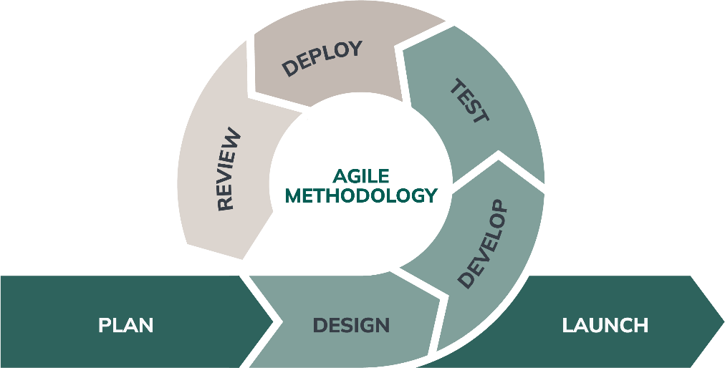

Figure 1.1: Agile Model

## 3.7 Cost Estimation

## 

## 3.7.1 Software Cost Estimation

For cost estimation, the COCOMO (Constructive Cost Estimation Model) is used.

Table 3.1: COCOMO model coefficients

|  |  |  |  |  |
| --- | --- | --- | --- | --- |
| **Software Category** | **A** | **B** | **c** | d |
| **Organic** | 2.4 | 1.05 | 2.5 | 0.38 |
| **Semi-detached** | 3.0 | 1.12 | 2.5 | 0.35 |
| **Embedded** | 3.6 | 1.20 | 2.5 | 0.32 |

**Software Project Category:** Semi-Detached

* **Estimated Lines of Code(LOC):**800LOC(**Flask Backend & Webhook Handling: 500 LOC** + **DeepSeek API Integration & Handling Requests: 300 LOC**) = 0.8 KLOC

**Effort applied** = a*(KLOC)b [Person-Months]=2.4(0.8)1.05 = 1.99PM(Person-Months) **Development Time** =c*(Effort)d = 2.5(1.99)0.38 = 2.68 months ≈ 124 days

**No: of Persons** = Effort / Development Time = 1.99 / 2.68 = 0.74 ≈ 1 person.

If ‘X’ is the salary of one person, then total development cost is 1×X×2.68 for this project.

## 3.8 Project Scheduling using Gantt chart

Table 3.2: Project timeline

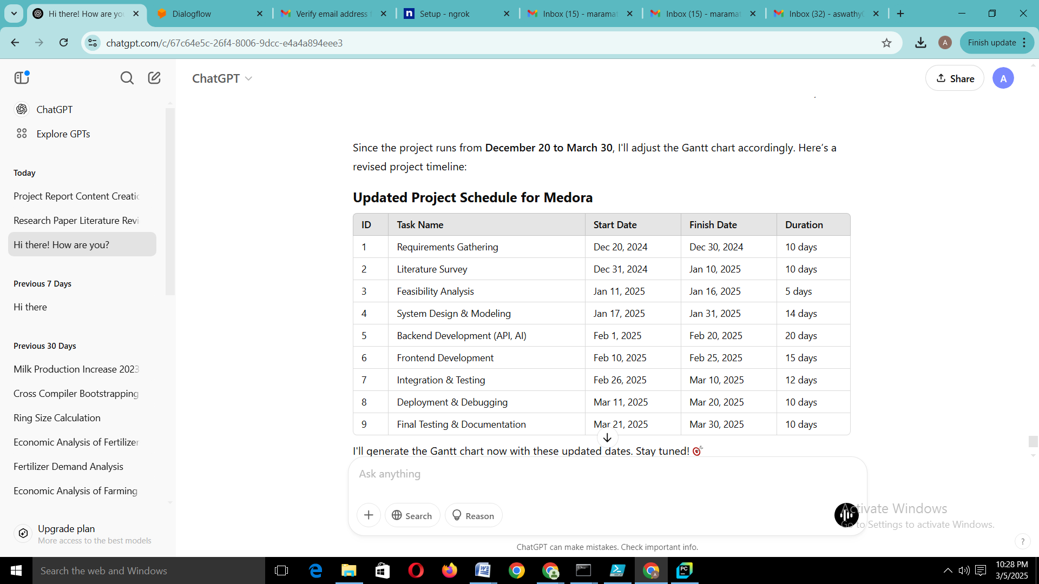

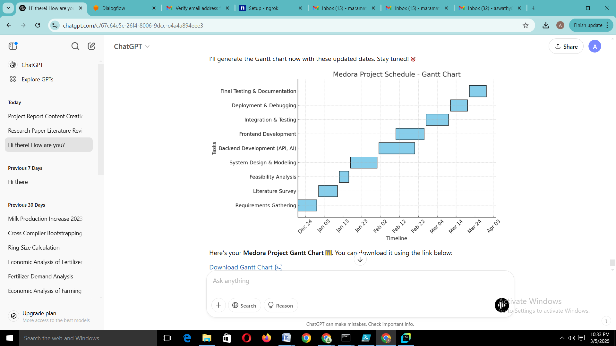

Figure3.2: Project Schedule using Gantt chart

The Gantt chart shows the project scheduling. Gantt chart shows the start and finish date of the project. The project phases will be completed as per the prescribed time schedule in the above Gantt chart shown in Figure 3.2. The starting date was 24/12/2024 and the project is expected to complete on 31/03/2025. .

# REFERENCES

1. Manikandan, S & Arun, G & Venkatesh, N & Sb, Vaidianathan. (2024). AI-Powered Healthcare Chatbot Using Natural Language Processing for Symptom Analysis and Medical Assistance. 2. 201–215.
2. Anwar, J., Nadi, P., & Seddik, N. (2025). Towards building a chatbot-based first aid service in Arabic language. Journal of Advanced Research in Applied Sciences and Engineering Technology, 45(2), 1-10. doi: 10.37934/araset.45.2.110.
3. Tathagat Yadav, “Design and Development a MediBot Disease Prediction Systen using Apriori algorithm and RNN”, Journal of Science, Computing and Engineering Research, 7(6), June 2024.
4. Chaturvedi U, Chauhan SB, Singh I, The Impact of Artificial Intelligence

on Remote Healthcare: Enhancing Patient Engagement, Connectivity, and Overcoming Challenges, Intelligent Pharmacy, https://doi.org/10.1016/j.ipha.2024.12.003.

1. Mughal, S. F., Aamir, S., Samad, A., Zehra, U., & Syed, A. A. (2025). Mai: A transformer-based domain-specific chatbot for menstrual health. ACM, 2832-0565, doi: 10.1145/3711711.
2. Almubark, I., "Exploring the Impact of Large Language Models on Disease Diagnosis," IEEE Access, vol. 13, pp. 8225-8238, Jan. 8, 2025, doi: 10.1109/ACCESS.2025.3527025.
3. M. Magnini, G. Aguzzi, and S. Montagna, "Open-source small language models for personal medical assistant chatbots," Intelligence-Based Medicine, vol. 11, p. 100197, 2025, doi: 10.1016/j.ibmed.2024.100197.
4. M. Huang and K. Scotland, "Usefulness and ease of use of an artificial intelligence chatbot for kidney stone formers," Cureus, vol. 17, no. 1, p. e77398, Jan. 13, 2025, doi: 10.7759/cureus.77398.
5. C. Cosma, A. Radi, R. Cattano, P. Zanobini, G. Bonaccorsi, C. Lorini, and M. Del Riccio, "Exploring Chatbot contributions to enhancing vaccine literacy and uptake: A scoping review of the literature," Vaccine, vol. 44, p. 126559, Jan. 12, 2025, doi: 10.1016/j.vaccine.2024.126559.
6. S. Nipu, K. M. S. Islam, and P. Madiraju, "How Reliable AI Chatbots are for Disease Prediction from Patient Complaints?" arXiv preprint arXiv:2405.13219v1, 21 May 2024. [Online]. Available: <https://doi.org/10.48550/arXiv.2405.13219>.
7. R. Jegadeesan, D. Srinivas, N. Umapathi, G. Karthick, and N. Venkateswaran, "Personal Healthcare Chatbot for Medical Suggestions Using Artificial Intelligence and Machine Learning," *Eur. Chem. Bull.*, vol. 12, no. S3, pp. 6004–6012, 2023, doi: 10.31838/ecb/2023.12.s3.670.
8. Z. Ni, M. L. Peng, V. Balakrishnan, V. Tee, I. Azwa, R. Saifi, L. E. Nelson, D. Vlahov, and F. L. Altice, "Implementation of Chatbot Technology in Health Care: Protocol for a Bibliometric Analysis," JMIR Res. Protoc., vol. 13, e54349, 2024, doi: 10.2196/54349.